**GIT Documentation**:

This document is describing, how to Clone/Pull/Commit/Push the code. I’ve prepared this document assuming we will be using Tortoise GIT.

**Clone the Repository:**

1. Copy the HTTPS clone URL from the GIT hub repository.

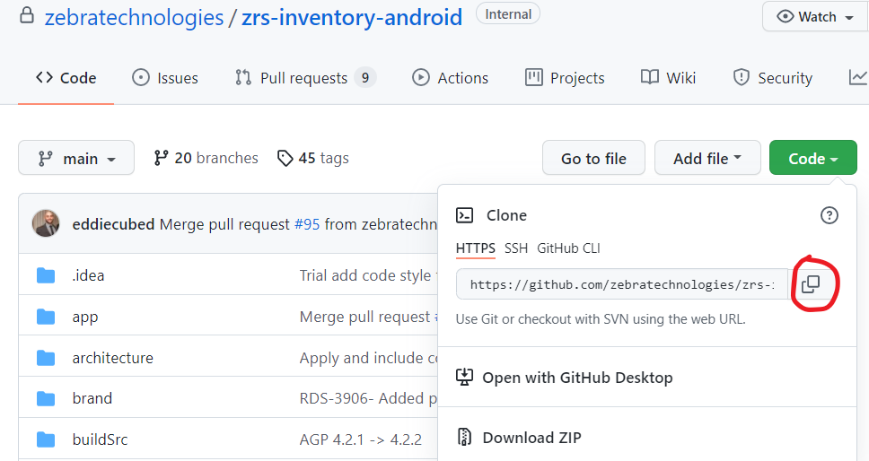

1. Create the folder in local machine, where you want to clone the code and open the newly created folder.
2. Right click in the folder, and select the option GIT Clone. Copied clone URL will be automatically populated in the URL section of GIT Clone dialog. (If you have already copied the HTTPS clone URL (from step 1), else you need to manually copy the clone URL and paste into URL section.)

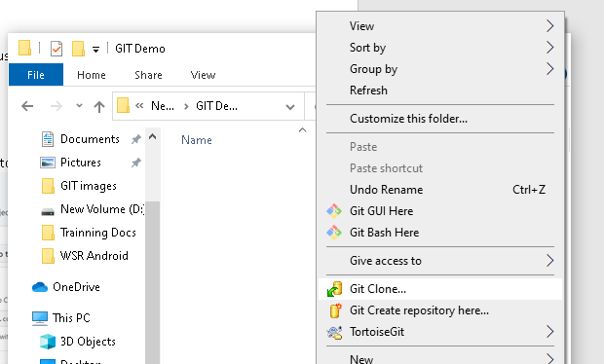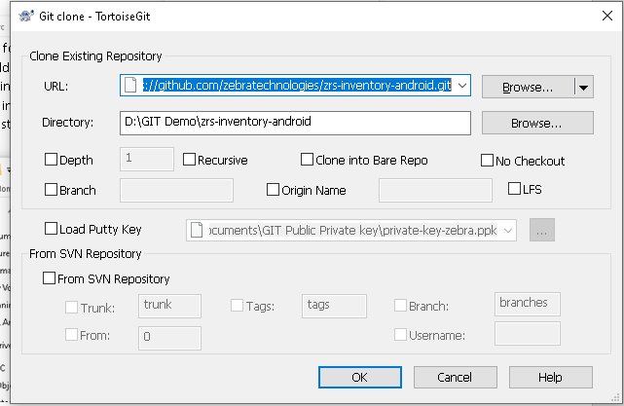

1. Click on the **OK.** And it will start cloning the Code Repo.

**Creating the Branch:**

Whenever you have assigned some ticket, we need to first create the branch on GIT before stating the coding.

1. Navigate to the Repository URL in google Chrome. In my case its, <https://github.com/zebratechnologies/zrs-inventory-android>
2. Click on the main branch button as shown in the diagram. There you will get the option to Find or create a branch.
3. Follow the proper naming convention while creating the branch. Generally, we should follow the naming convention as: **{ticket_id}_{small ticket description}**

**Ex: RDS-4767_update_retrofit_version**

1. Paste branch name in the text view & click on the Create Branch. Your branch will be created.

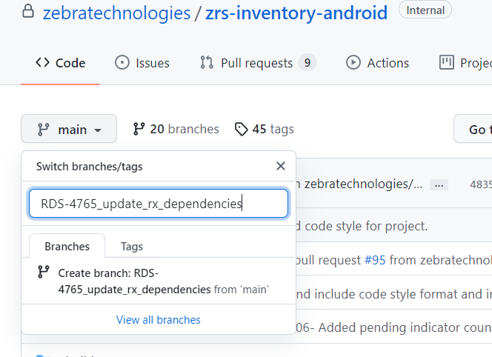

NOTE: Newly created branch will not be directly visible to you while switching on to the newly created branch. For switching to the newly created the branch you have to Fetch the branch, so that it will cached.

**Fetching the Branch:**

1. Go to the File explorer and open the code repo, where you have clone the code.
2. Right click in anywhere (not on any file).
3. Select TostoiseGit and select Fetch option.
4. You will be prompted to **Fetch – TortoiseGit dialog**  and select OK button
5. GIT fetch will be start and after completion, fetch completed dialog will be prompted. Close that dialog.

Now you will have the links of all the newly created branch in your local machine GIT copy.

**Switching the Branch:**

1. Go to the File explorer and open the code repo, where you have clone the code.
2. Right click in anywhere (not on any file).
3. Select TostoiseGit
4. select Switch/Checkout
5. Select the **…** option as shown in image from the Branch tab.

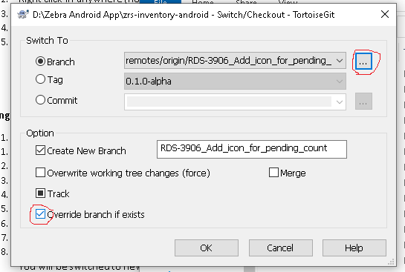

1. Select the Remote under the Refs. And type the branch name you want to switch.
2. Select the branch and press OK.

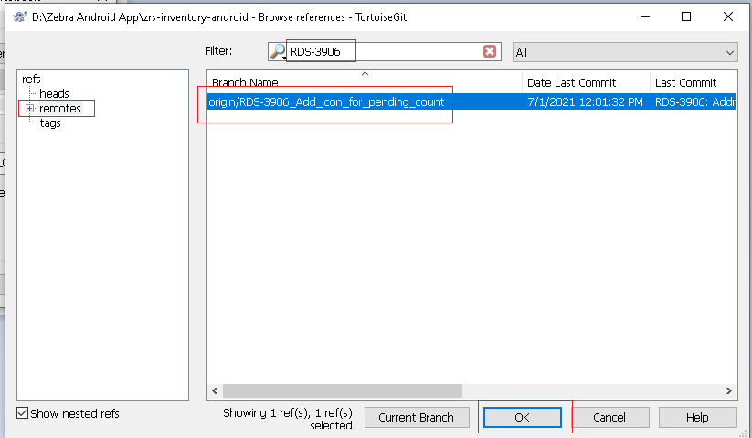

1. Make sure under the option tab, Override branch if exists option should be checked as shown in above image.
2. Press OK.

You will be switched to newly created branch.

**NOTE:** Also, you can verify your current branch by right clicking on anywhere on the blank area in folder, you will see **GIT Commit -> {current_branch_name}**

**Commit and Push the Code:**

Make a code changes in IDE. And follow the above common steps from **Step 1 to Step 3**

1. Select the Git Commit. You will be prompted Commit TotrtoiseGit dialog as shown in below.
2. Select the files that you want to commit onto the branch.
3. In the message section, write the short but meaningful message describing what’s the commit is about. And select the commit button.

**NOTE: Naming convention for message should be like {ticket_id: commit message}**

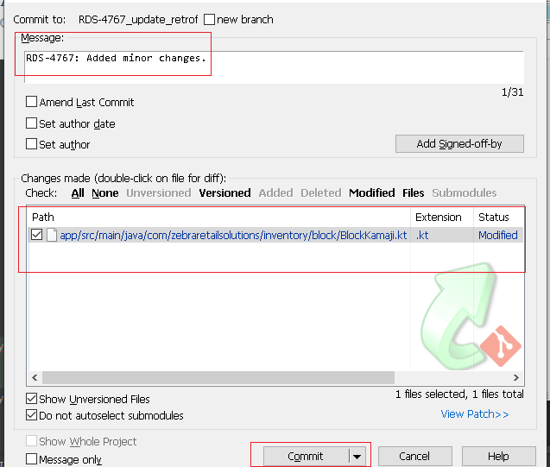

1. After successfully committing the code, you will be prompted a Push Tortoise Git dialog, click the Push button and your code will be get pushed into the branch.

**Creating Pull Request:**

1. Once you Pushed the code, you can select the branch from the Github repository (where you have committed the code) as shown in image.

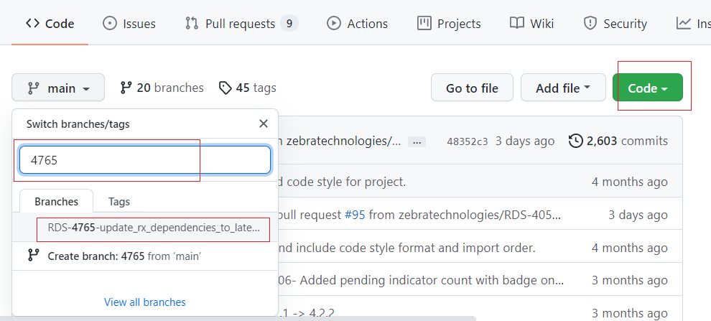

1. Select Contribute option.
2. Click on Compare button. You will be navigating to Comparing changes page. Where you can see all your commits and file changes.

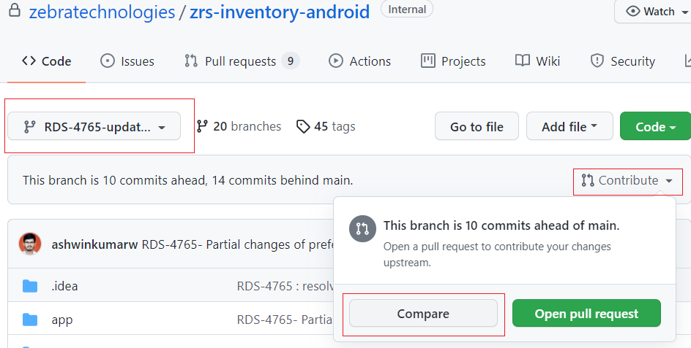

1. Click on create Pull Request. In the Write section, you have to fill the PR format. Like

* Jira issue which satisfies the PR
* Description of your changes
* How you have tested this PR
* And Fill the prepopulated checklist.

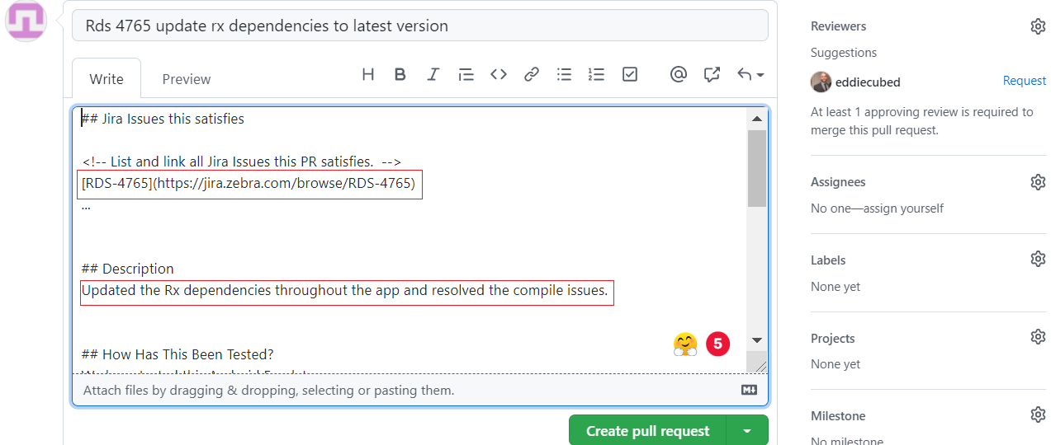

Your preview section will appear as:

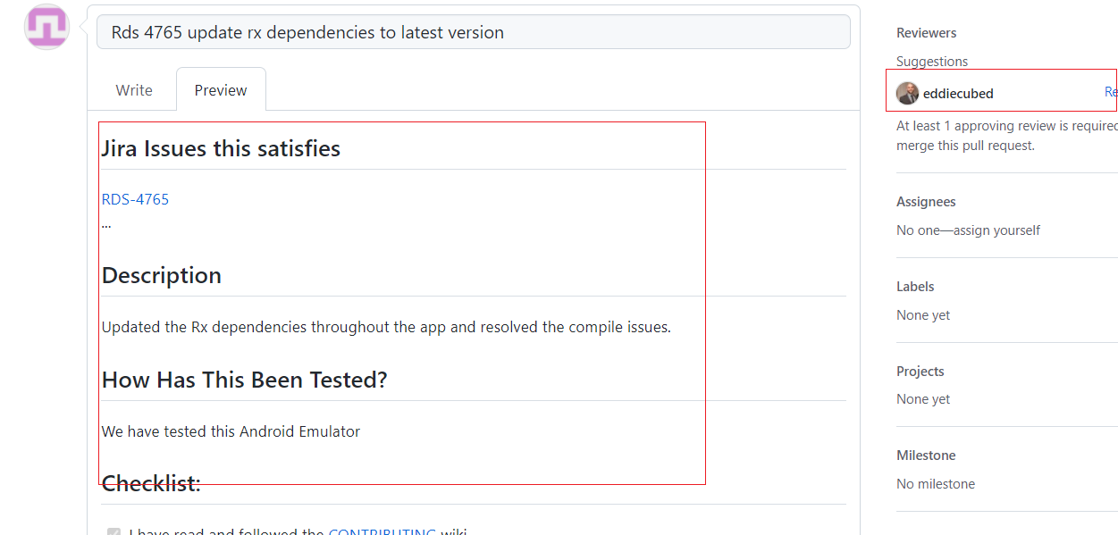

1. At the end mention the reviewer that you want to tagged as a reviewer in Write section.
2. Click on Create Pull Request.
3. You should also have tagged the reviewer name in Reviewers section.